Addis Ababa University
Science Faculty
Department OF MATHEMATICS
Math 231: Applied Mathematics I
Final Examination

Date: March 25, 2007
Time: 1:30 – 4:30 P.M.

Name_____________________________ I.D. No. _________________

Department: ___________________________

Instructions: This examination has two parts, part I and Part II.

Part I has 20 short answer questions worth 3 points each to be answered in the blank spaces following each question.

Part II, worth a total of 40 points has 5 workout problems, each problem allotted the points shown against it. Show all necessary steps and write clearly in the spaces provided for each problem.

Make Sure that your exam-Paper has 9 pages

For Instructor’s use Only

Part I | Part II |  |  |  |  | Total
Part I | 1 | 2 | 3 | 4 | 5 | Total

Part I: Short answer questions

- If v = ⟨1, 0, 1 ⟩, w = ⟨0, 1, -1⟩ then
  - || 2v + w || = _________________
  - the angle between v and w = _______________
- If π₁ : x + y – z + 1 = 0 and π₂ : -x + 2y + z - 1 = 0 the angle between π₁ and π₂ = ___________________
- If v and w are any two non-zero and non-parallel vectors in ℜ³ then
  - v × (w × w) = _____________
  - a vector orthogonal to both v and w = ______________
- If v = ⟨x, -3, 1⟩, w = ⟨x, x, 2⟩ , v and w are orthogonal then the possible value(s) of x = _____________________
- The equation of the plane π₁ through the point (1, 2, 3) and parallel to the plane π₂ : 2x + 3y – z – 5 = 0 is ____________________
- If A = [ai_{j}]_{m × n}, B = [bi_{j}]_{2 × 3} and the product BAB^{t} is defined then
a) m = ______________ b) n = ________________
- If A = 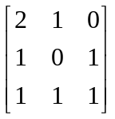 then rank A = __________________
- If A = 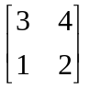 then A⁻¹ = ____________________
- If A and B are matrices such that det A = 2 and det AB = 6 then
a) det B² = _____________ b) det B⁻¹ = _______________
- The homogeneous linear system
3x – y + 2z = 0
kx + 4y + 5z = 0
3x – y + 3z = 0
has a non-trivial solution if k = _____________________

- a) 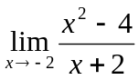 = _______________
b) 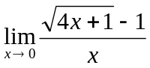 = _____________
- a) If f(x) = 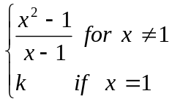
f is cont at x = 1 if k = ________________
b) If f(x) = 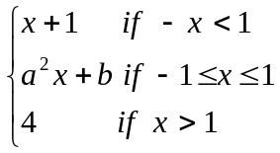
f is cont on R = D_{f} if a = _____________ and
b = ____________
- a) 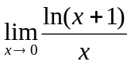 = _______________________
b) 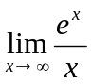 = __________________
- If f(x) = sinh (cos x²) then
  - ƒ′(x) = ______________________
  - ƒ′′(x) = ______________________
- If f(x) = n (secx + tanx) then
  - ƒ′(x) = __________________
  - ƒ′′(x) = __________________
- If f(x) = tan⁻¹(e^{2x}) then ƒ′(x) = ______________________
- If x³ + 2y² = 6xy then y′ = __________________________
- 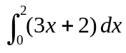= _________________________
- 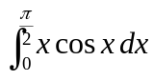 = _________________________
- 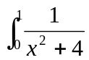dx= _________________________
Part II : Workout Problems
1. a) Show that the plane π: 4x – 4y – z – 1 = 0 contains the line
L: (1, 1, -1) + t (2, 1, 4) completely.
Hint: Two pts determine a line completely (3 pts)

- Show that the lines L₁ : (1, -3, -2) + t₁(1, -1, -1) and
L₂ : (17, 4, -8) + t₂ (3, 1, -1) are neither parallel nor intersecting. (4 pts)

- Solve the following system of linear equations using matrix algebra (i.e. using the determinant and the adjoint of the matrix of coefficients). (8 pts)
x + 2y – z = 6
2x – y + 4z = 2
4x + 3y – 2z = 14

- a) Use the ε - δ definition of the limit of a function to show that
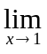2x + 1 = 3 (3 pts)

  - If f(x) = 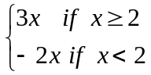
show that f is not continuous at x = 2 (3 pts)

4. a) Use the definition of the derivative of a function to show that f defined by f(x) = | x + 5 | is not differentiable at x = -5 (3 pts)

b) Sketch the graph of f(x) = 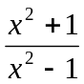 after clearly indicating each of the following;
i) Domain f,
ii) Intercepts, if any,
  - Asymptotes, if any,
  - Local exrema, if any,
  - Intervals of monotonicity,
  - Intervals of concavity
  - Points of inflection if any. (10 pts)

    - Evaluate the following integrals
a) 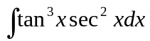 (3 pts)

b) 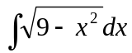 (3 pts)

